Title: | <Window Lifter>  SW Component < XXXXXXX >

History
Issue status  (Index) | Maturity/Date  (draft/invalid/valid)  (dd-mmm-yyyy) | Author  Department | Check/Release  Department | Description
3.0 | Draft  26-Jun-15 | Roberto Palos | Roberto Palos | Creation of the document

Table of Contents
1 Purpose 3
2 Definitions and abbreviations 3
3 Realization constraints and targets 3
4 SW Conceptual design 3
5 SW Component internal breakdown 4
5.1 Functional Decomposition 4
5.2 Function <Type> <function name> (type par 1, .., type par n) 5
5.3 Function <Type> <function name> (type par 1, .., type par n) 5

Purpose
This document has the purpose to specify the function of the module that control the window, called window lifter. Also this document describes the functions based on the requirements.

Definitions and abbreviations
Definitions
Window Lifter  Anti-pinch  Debounce | Module capable to control the movement of the window.  Special function to prevent accidents between window and body parts.  Function that detects fail safe buttons pressed.

Abbreviations
SW Software
HW Hardware
GPIO General Purpose Input / Output
uC Microcontroller
References
N° | Document name | Reference
1 | SW Architecture description

Realization constraints and targets
The purpose of this module is to control the window movement by the final user. The user has access to two buttons: Up and Down. When the user press any button the module can enter in two different options depending of the time the button last pressed, these options are automatic and manual. In manual option, the window will keep going Up/Down until the user keep pressed the button. In automatic option, the window will go to fully closed/open. This module have a protection called anti-pinch that can occur only when the window is going up (doesn’t matter if its manual or automatic) prevent the window to going up (closing) and force the window to go down and when is totally open the system will ignore any signal for 5 seconds and then accept any signal.

SW Conceptual design

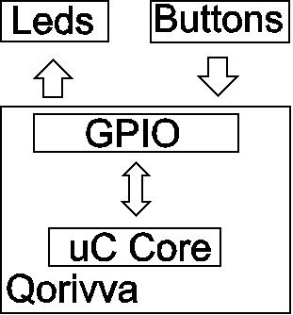

SW Component internal breakdown
For complex SW Components, the designer may define SW Subcomponents. Please consider also the work step "Deal

Functional Decomposition
Overview of functions and their dependencies shown by a Static Function Tree
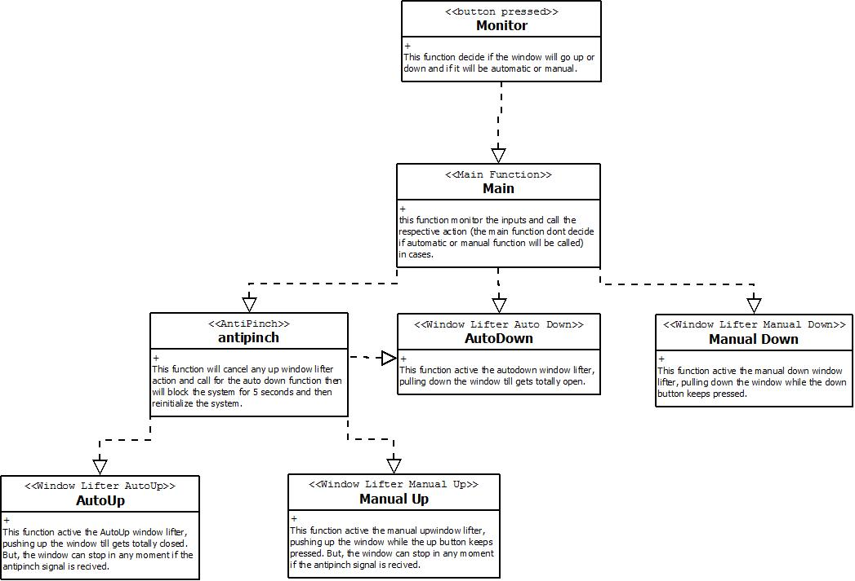
Function Description and Dynamic Behavior
Provide detailed static and dynamic description of all functions of the SW Component.
Functions which are defined in other SW Components shall only be referenced in the external interface description!
The signature description shall be done inside the function header in the source code.
For each function, the following section should be copied

Function void DisableWatchdog(void)
Description | Disable watchdog to prevent fail reboot from microcontroller.
Return Value | Void
Precondition | None
Post condition | None

Function void InitTimer(void)
Description | Register Configuration for MT Module.
Return Value | Void
Precondition | None
Post condition | None

Function void InitModesAndClock(void)
Description | Enable DRUN, RUN0, SAFE, RESET modes. Enable 8Mhz xtal. And verify RUN0 is the current mode
Return Value | Void
Precondition | None
Post condition | None

Function void InitPeriClkGen(void)
Description | Enable peri set 3 sysclk divided by 1.
Return Value | Void
Precondition | None
Post condition | None

Function void InitSysclk(void)
Description | Call for the InitModesAndClock andInitPeriClkGen function
Return Value | Void
Precondition | None
Post condition | None

Function void InitGPIO(void)
Description | Configure inputs and outputs that will be used in the system.
Return Value | Void
Precondition | InitSysclk must be called before initialize the GPIO.
Post condition | None

Function void InitLeds(void)
Description | Initialize the leds in the best case (window totally closed)
Return Value | Void
Precondition | GPIO’s must be initialized before.
Post condition | All outputs must be activated (except blue and green led)
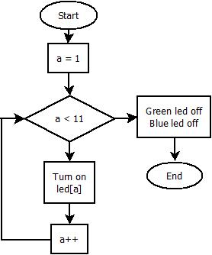

Function void InitHW(void)
Description | Only call for all functions to initialize the hardware and keep the microcontroller in the ideal condition (window totally closed) (DisableWatchdog(), InitSysclk(), InitTimer(), InitGPIO(),InitLeds().
Return Value | Void
Precondition | None
Post condition | All hardware initialized.

Function void downmanual(void)
Description | Function that pulls down the window while the button keeps pressed.
Return Value | Void
Precondition | At least 1 steps up the window.
Post condition | At least 1 level down he window.

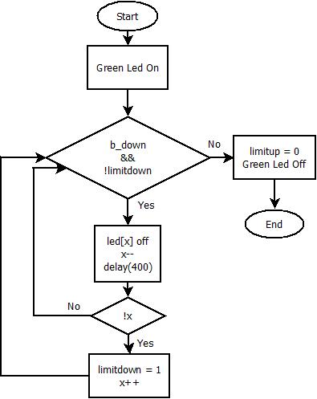

Function void autodown(void);
Description | Function that pulls down the window till gets totally open.
Return Value | Void
Precondition | At least 1 steps up the window.
Post condition | Window totally open.

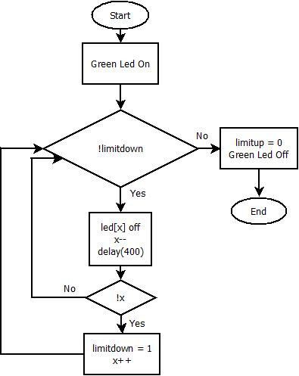

Function void upmanual(void)
Description | Function that push up the window while the button keeps pressed.
Return Value | Void
Precondition | Window cant be totally closed.
Post condition | At least 1 steps up the window.
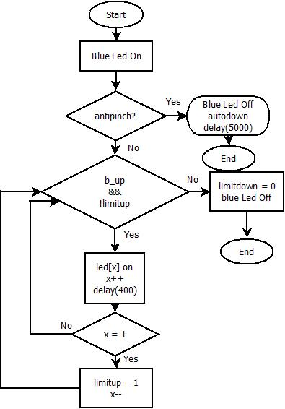

Function void autoup(void)
Description | Function that push up the window till gets totally closed.
Return Value | Void
Precondition | Window cant be fully closed.
Post condition | Window will get totally closed.

